ASSIGNMENT 2

|  |  |
| --- | --- |
| **DATE** | **26 SEPTEMBER 2022.** |
| **PROJECT NAME** | **AI based discourse for Banking industry** |
| **NAME** | **Prathap D** |

1..Download the dataset

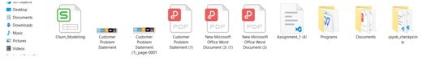

1. Load the dataset

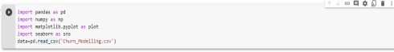

1. perform below visualization
   * Univarient
   * Bi-varient
   * Multi-varient

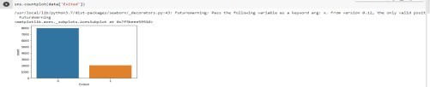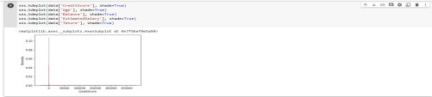

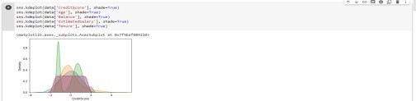

1. 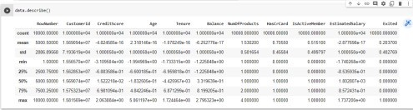Perform the descriptive statistics on the datase
2. Handle the missing values

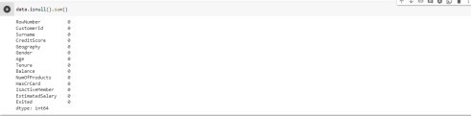

1. Find the outliers and replace the outliers

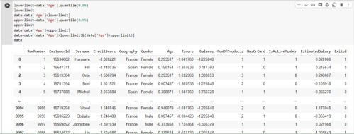

1. Check the categorical columns and perform encoding

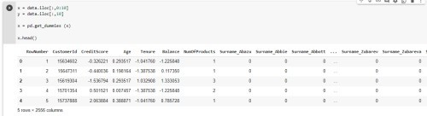

1. Split the dataset into ipdendent and dependent variables.

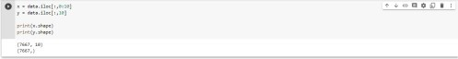

1. Scale the independent variable

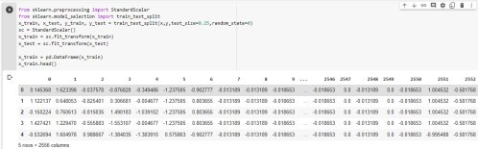

1. Split the data into training and testing.

